Plate Boundaries Guided Notes
Why do plates move?
- Mantle ____________ _________________
- __________ _________ - cold dense plates sink and pull the rest of the plate down at a trench
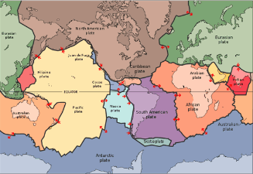
- __________ _________ - plates are pushed due to the force of gravity at a ridge
What is a plate boundary?
- A plate boundary is the ________________ between two plates
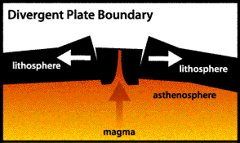
Divergent Boundaries – CREATE LITHOSPHERE!
- Plates __________ __________ and mantle material fills gaps
  - __________ ___________: new mantle material rises and elevates the seafloor
  - __________ ___________: deep faults where continental plates pull apart
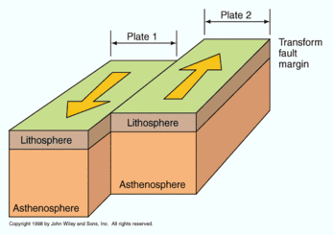
  - Continental Rifts: landmass splits into two _____________ _____________
Transform Fault Boundaries – NEITHER CREATE NOR DESTROY LITHOSPHERE!
- Plates ___________ _________ each other without destroying or creating lithosphere
- ____________________!
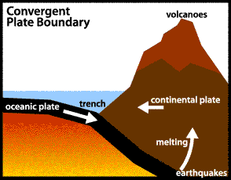
Convergent Plate Boundaries – DESTROY LITHOSPHERE
- A boundary in which two plates __________ ___________
  - Oceanic-continental boundaries create ________________ and _________________
  - Continental-continental boundaries create _________________
Plate Boundary | What happens? | Create or Destroy Lithosphere? | What landforms are created? | Draw it!

